Ime i prezime: _______________________________________________

- PREPIŠI REČENICE PISANIM SLOVIMA !!

ZLATKO IMA VELIKOG ZEKU.
ZEKO NOSI MALU KOŠARU.
U KOŠARI SU ZLATNE PISANICE.

________________________________________________________________________________________________________________________________________________________________________________________________________________________________________________________________________________________________________________
________________________________________________________________________________________________________________________________________________________________________________________________________________________________________________________________________________________________________________
________________________________________________________________________________________________________________________________________________________________________________________________________________________________________________________________________________________________________________

- NAPIŠI ŠTO VIDIŠ NA SLICI !
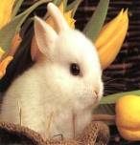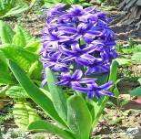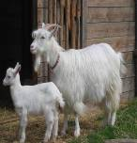
_______________________ _______________________ ______________________
_______________________ _______________________ ______________________
_______________________ _______________________ ______________________
_______________________ _______________________ ______________________

- SPOJI POČETAK I KRAJ REČENICE. SPOJENE REČENICE PREPIŠI PISANIM SLOVIMA!
ZORAN VOZI U ZRAKOPLOVU.
ZLATKO I ZLATA ZELENI AUTO.
TATA JOZO JE CRTAJU ZEKU.
________________________________________________________________________________________________________________________________________________________________________________________________________________________________________________________________________________________________________________________________________
________________________________________________________________________________________________________________________________________________________________________________________________________________________________________________________________________________________________________________________________________
________________________________________________________________________________________________________________________________________________________________________________________________________________________________________________________________________________________________________________________________________
pisanice
cvijeće
zeko
leptir
- DOPUNI REČENICE UZ POMOĆ PONUĐENIH RIJEČI !
Maja i Marta u vrtu sade _________________________.
U šumi veselo skače mali _________________________.
Oko cvijeta leti šareni _____________________________.
U košari su šarene ________________________________.

- OBOJI SLIKU !!!
