Ime i prezime: __________________________________________________
Radni listić
- PREPIŠI REČENICE PISANIM SLOVIMA
GOLUB SJEDI NA GRANI.
HRČAK JE U KUĆICI.
DJED SADI MLADO DRVO.
BAKA JE U VRTU.
MAJA IMA NOVU VESTU.
U ŠUMI JE LUKAVA LISICA.
________________________________________________________________________________________________________________________________________________________________________________________________________________________________________________________________________________________________________________________________________
________________________________________________________________________________________________________________________________________________________________________________________________________________________________________________________________________________________________________________________________________
________________________________________________________________________________________________________________________________________________________________________________________________________________________________________________________________________________________________________________________________________
________________________________________________________________________________________________________________________________________________________________________________________________________________________________________________________________________________________________________________________________________
________________________________________________________________________________________________________________________________________________________________________________________________________________________________________________________________________________________________________________________________________
________________________________________________________________________________________________________________________________________________________________________________________________________________________________________________________________________________________________________________________________________
- NAPIŠI SAMOSTALNO JEDNU REČENICU O SVAKOJ SLICI
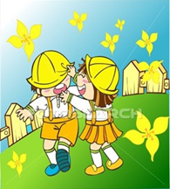

________________________________________________________________________________________________________________________________________________________________________________________________________________________________________________________________________________________________________________
________________________________________________________________________________________________________________________________________________________________________________________________________________________________________________________________________________________________________________
________________________________________________________________________________________________________________________________________________________________________________________________________________________________________________________________________________________________________________

- PROMOTRI SLIKU I ODOGOVRI NA PITANJA PUNOM REČENICOM?
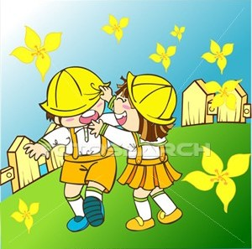
GDJE SE IGRAJU DJECA ?
GDJE SE TI NAJVIŠE VOLIŠ IGRATI?

________________________________________________________________________________________________________________________________________________________________________________________________________________________________________________________________________________________________________________________________________
________________________________________________________________________________________________________________________________________________________________________________________________________________________________________________________________________________________________________________________________________

